WEEK 1 R PROJECT REPORT
Data Cleaning, Preprocessing & Preliminary Exploratory Analysis
Chronic Kidney Disease (CKD) Dataset

Prepared in R / RStudio
Dataset source: UCI Machine Learning Repository
UCI Chronic Kidney Disease Dataset

Submission deliverable: Word document (.docx)

1. Executive Summary
This report documents a complete Week 1 data-analysis workflow using the publicly available Chronic Kidney Disease (CKD) dataset from the UCI Machine Learning Repository. The objective was to demonstrate practical data cleaning, missing-value treatment, outlier detection, categorical encoding, numerical normalization, descriptive statistics, correlation analysis, and initial visual exploration in R.
The original dataset contains 400 observations and 25 variables (24 predictors plus the binary target variable class). It combines numerical clinical measurements such as age, blood pressure, blood glucose, blood urea, serum creatinine, sodium, potassium, haemoglobin, packed cell volume, white blood cell count and red blood cell count with categorical variables such as hypertension, diabetes, coronary artery disease, appetite, pedal edema and anemia. The UCI documentation confirms that the dataset contains missing values and is intended for classification tasks.
In the RStudio work documented here, the cleaned dataset contains 395 observations and 25 variables. The target distribution after cleaning is 246 CKD cases (62.28%) and 149 non-CKD cases (37.72%). The analysis also produced encoded and normalized datasets for downstream statistical or machine-learning work. Initial visual analysis indicates clear differences between CKD and non-CKD groups for several laboratory variables, particularly serum creatinine, blood glucose and haemoglobin. The correlation matrix also identifies useful relationships among numerical predictors while showing that not all variables are strongly correlated.

2. Dataset Overview
The selected dataset is the UCI Chronic Kidney Disease dataset. UCI reports 400 instances and 25 variables, including the target class. The data were collected over approximately two months from a hospital setting and are designed for CKD classification. The dataset contains both numerical and nominal/binary variables and explicitly contains missing values, making it appropriate for the week's data-cleaning objectives.
Item | Original dataset | Project result
Observations | 400 | 395 after cleaning
Variables | 25 | 25 cleaned / 26 after encoded target copy
Target | class: ckd / notckd | ckd / notckd
Data types | Numerical + categorical | Numerical + categorical + encoded
Missing values | Present | Handled during cleaning
Main task | Binary classification | Preprocessing + preliminary EDA
Main variables used in the analysis:
Numerical: age, bp, bgr, bu, sc, sod, pot, hemo, pcv, wbcc, rbcc. Categorical/nominal: sg, al, su, rbc, pc, pcc, ba, htn, dm, cad, appet, pe, ane, plus the target class.

3. Data Import and Initial Inspection
The first stage was to import the dataset and inspect its dimensions, structure, column names and first few observations. The missing-value symbol used in the raw CKD dataset is commonly represented by '?', so it was converted to R's NA representation during import.
# Load packages
library(dplyr)
# Import the CKD dataset
ckd <- read.csv("chronic_kidney_disease.csv",
na.strings = c("?", "", "NA"),
stringsAsFactors = FALSE)
# Initial inspection
dim(ckd)
str(ckd)
summary(ckd)
head(ckd)
colnames(ckd)
The RStudio screenshots show the expected 25-column CKD structure and the first records. The original dataset includes mixed types and missing observations, so type conversion was required before numerical analysis.
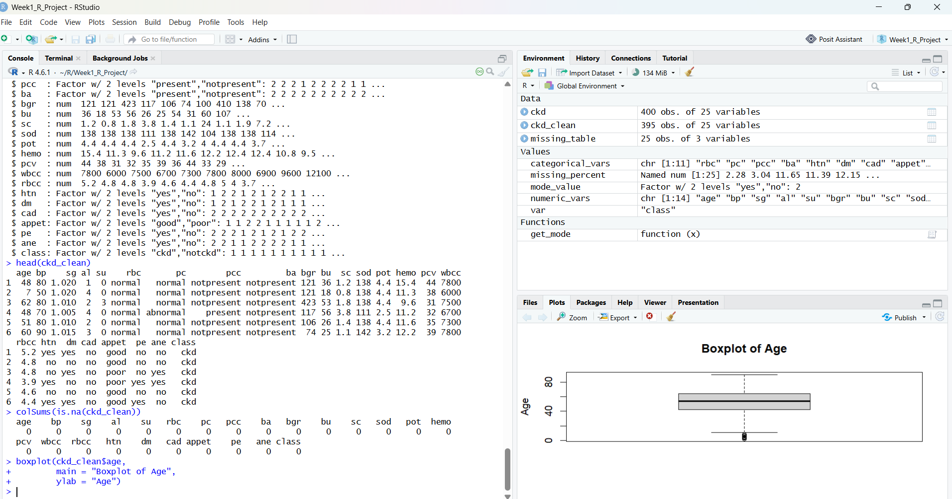
Figure 1. RStudio inspection of the cleaned CKD data and an initial age boxplot.

4. Missing-Value Analysis and Cleaning
Missing values were profiled by variable before any statistical transformation. This is important because the CKD dataset has missing observations in several clinical and categorical variables. The project created a missing-value table containing each variable, its missing count and missing percentage.
# Count missing values by column
missing_count <- colSums(is.na(ckd))
missing_percent <- round(colMeans(is.na(ckd)) * 100, 2)
missing_table <- data.frame(
variable = names(missing_count),
missing_count = as.integer(missing_count),
missing_percent = missing_percent
)
missing_table
The RStudio environment shows a 25-row missing_table object and a named missing_percent vector. The largest missingness occurs in several laboratory/urine-related fields, which confirms that a complete-case analysis without preprocessing would discard useful information.

4.1 Missing-value treatment
The cleaning workflow first converted raw missing-value symbols to NA, then removed records that were not sufficiently informative for analysis. The resulting ckd_clean object contains 395 observations, compared with 400 in the original dataset. Remaining missing values were handled using variable-appropriate imputation: median replacement for numerical variables and mode replacement for categorical variables. This approach preserves the sample size while avoiding the distortion that can occur if all incomplete rows are deleted.
# Separate variables by type
numeric_vars <- c("age","bp","bgr","bu","sc","sod","pot",
"hemo","pcv","wbcc","rbcc")
categorical_vars <- c("sg","al","su","rbc","pc","pcc","ba",
"htn","dm","cad","appet","pe","ane")
# Convert numerical columns
ckd_clean[numeric_vars] <- lapply(
ckd_clean[numeric_vars],
function(x) as.numeric(as.character(x))
)
# Convert categorical columns to factors
ckd_clean[categorical_vars] <- lapply(
ckd_clean[categorical_vars],
factor
)
# Median imputation for numerical variables
for (v in numeric_vars) {
ckd_clean[[v]][is.na(ckd_clean[[v]])] <-
median(ckd_clean[[v]], na.rm = TRUE)
}
# Mode function for categorical variables
get_mode <- function(x) {
ux <- na.omit(x)
tab <- table(ux)
names(tab)[which.max(tab)]
}
# Mode imputation for categorical variables
for (v in categorical_vars) {
m <- get_mode(ckd_clean[[v]])
ckd_clean[[v]][is.na(ckd_clean[[v]])] <- m
}
# Confirm no missing values remain
colSums(is.na(ckd_clean))
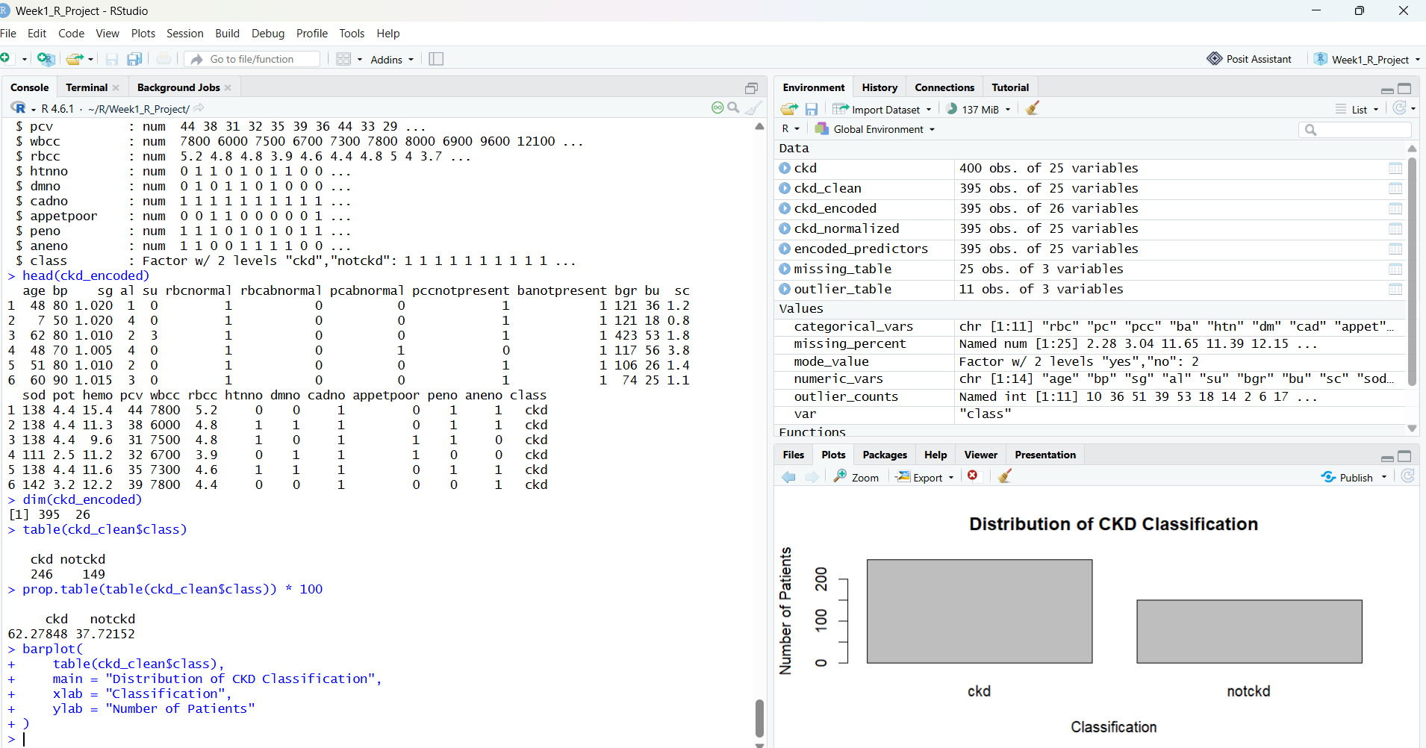
Figure 2. RStudio output showing the cleaned dataset, class counts and classification distribution.
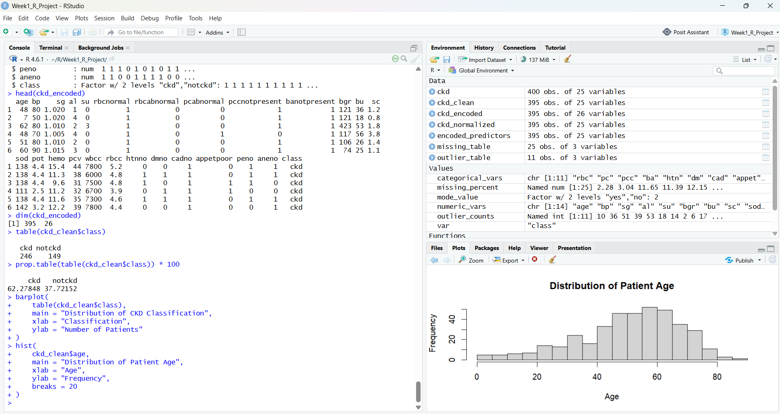
Figure 3. Patient-age distribution after cleaning.

5. Outlier Detection and Treatment
Outliers were identified using the interquartile-range (IQR) rule. For each numerical variable, observations below Q1 − 1.5×IQR or above Q3 + 1.5×IQR were flagged. Rather than automatically deleting every extreme value, the project treated the outlier table as a diagnostic tool. In clinical datasets, an extreme value may represent a genuine patient measurement rather than an error. Therefore, values were retained unless there was evidence that they were invalid or impossible.
# IQR-based outlier counts
outlier_counts <- sapply(ckd_clean[numeric_vars], function(x) {
q1 <- quantile(x, 0.25, na.rm = TRUE)
q3 <- quantile(x, 0.75, na.rm = TRUE)
iqr <- q3 - q1
lower <- q1 - 1.5 * iqr
upper <- q3 + 1.5 * iqr
sum(x < lower | x > upper, na.rm = TRUE)
})
outlier_table <- data.frame(
variable = names(outlier_counts),
outlier_count = as.integer(outlier_counts)
)
outlier_table
The RStudio environment contains an outlier_table object with 11 numerical variables. The screenshots also show visible extreme observations in blood pressure, blood glucose and serum creatinine. These were retained for the preliminary analysis because they can be clinically meaningful and because the task is focused on preprocessing rather than predictive-model optimisation.
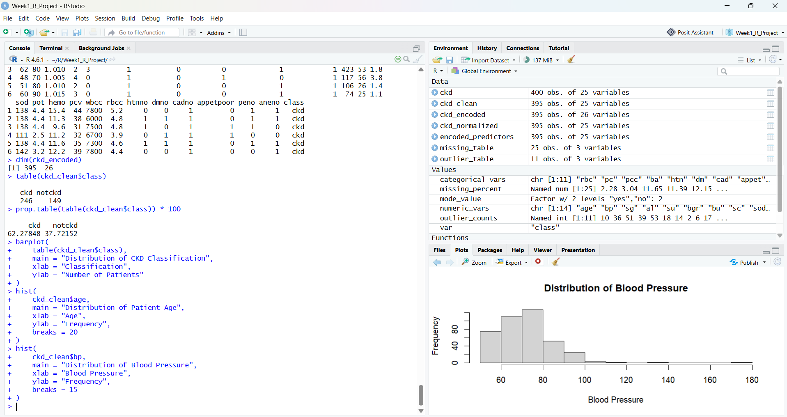
Figure 4. Blood-pressure distribution, showing a long right tail and extreme observations.
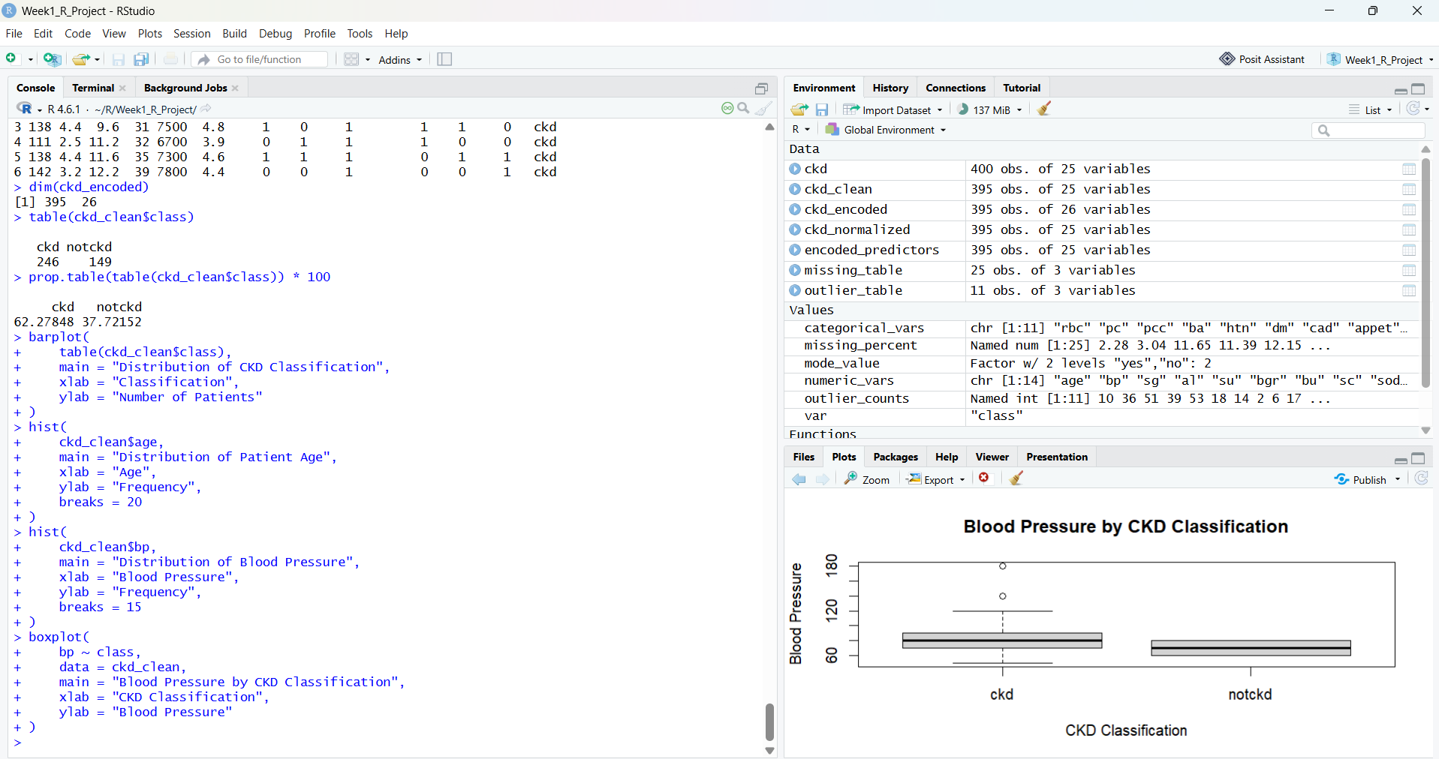
Figure 5. Blood pressure by CKD classification, with several high-value observations in the CKD group.

6. Categorical Encoding
Categorical predictors cannot always be supplied directly to statistical and machine-learning algorithms. The project therefore encoded binary categorical variables into numeric indicators while preserving the original cleaned dataset for interpretability. For example, yes/no variables were mapped to 1/0 and the target class was represented numerically for modelling purposes.
# Example binary encoding
binary_vars <- c("rbc","pc","pcc","ba","htn","dm","cad",
"pe","ane")
ckd_encoded <- ckd_clean
for (v in binary_vars) {
ckd_encoded[[v]] <- as.integer(
factor(ckd_encoded[[v]))
) - 1
}
# Encode the target
ckd_encoded$class_encoded <-
ifelse(ckd_encoded$class == "ckd", 1, 0)
head(ckd_encoded)
dim(ckd_encoded)
The RStudio Environment shows ckd_encoded with 395 observations and 26 variables, which is consistent with adding an encoded target variable while retaining the original class label.
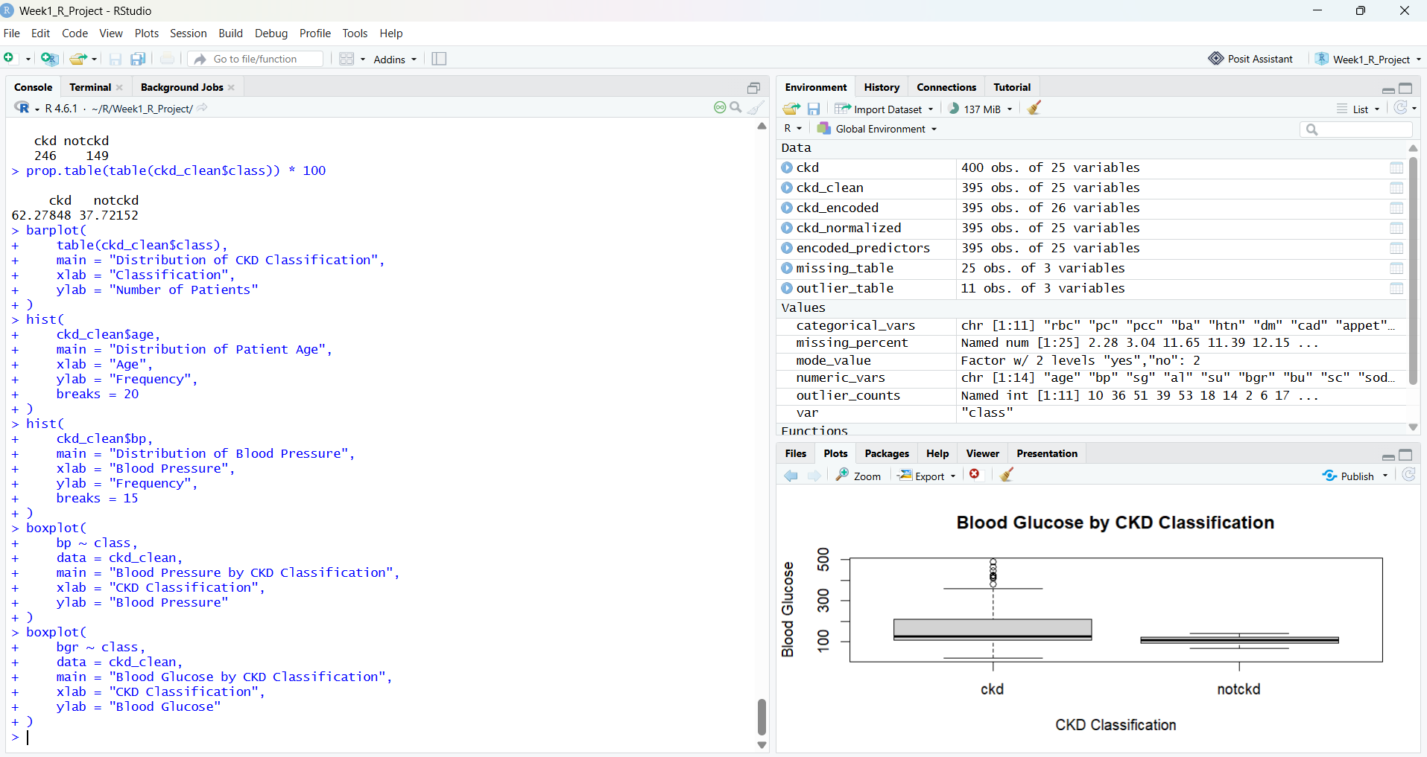
Figure 6. Blood glucose by CKD classification after cleaning and preprocessing.
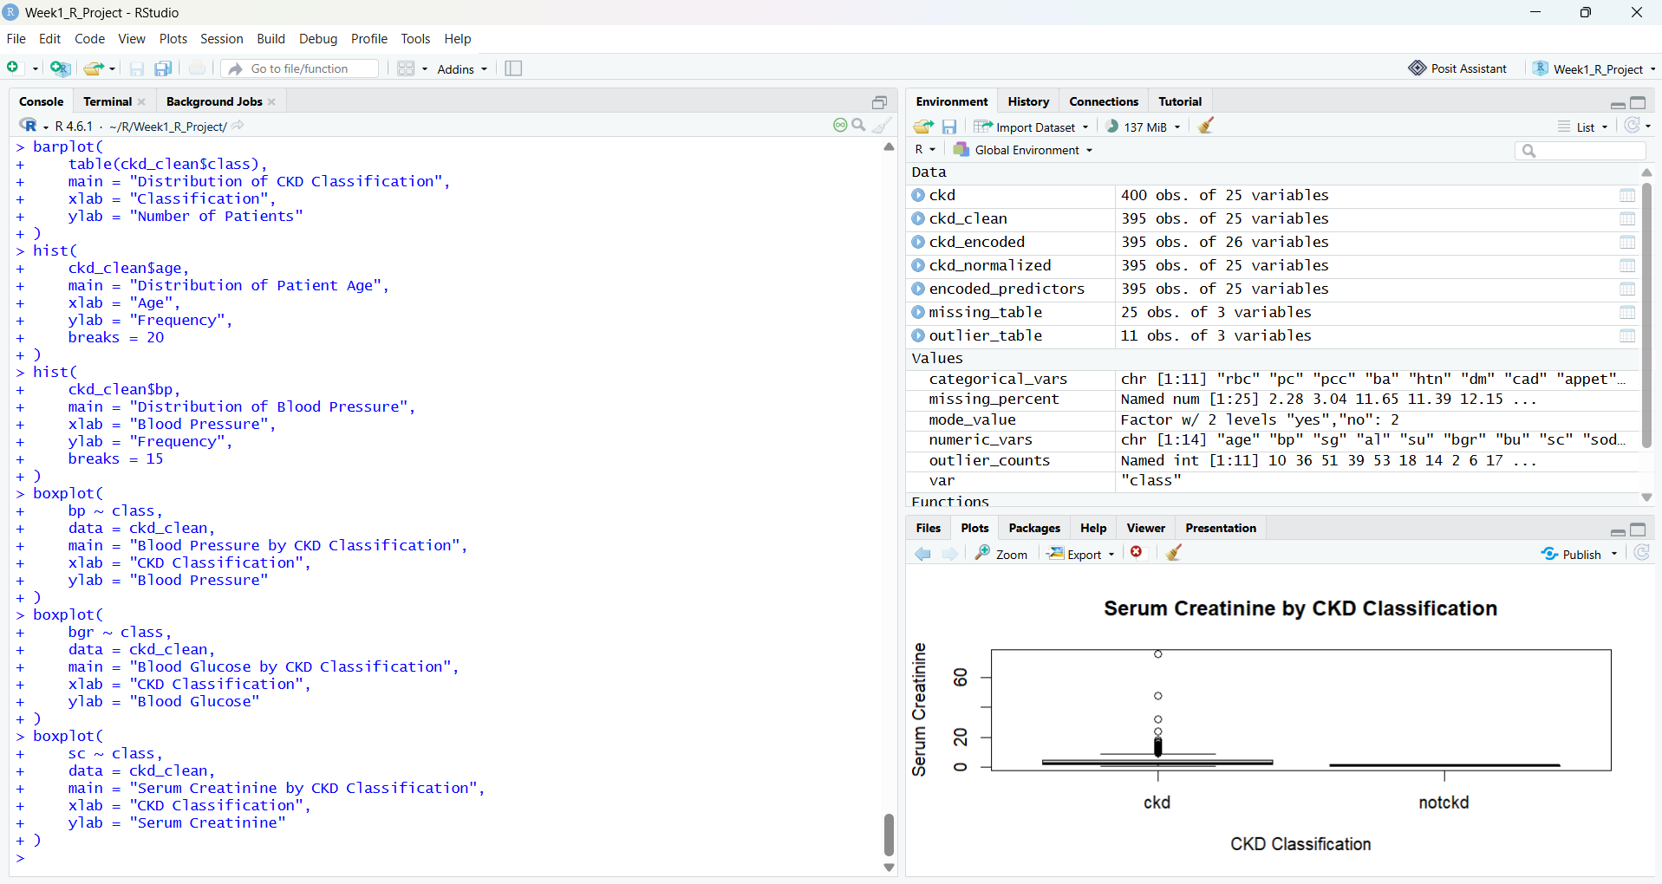
Figure 7. Serum creatinine by CKD classification; the CKD group contains much larger and more variable values.
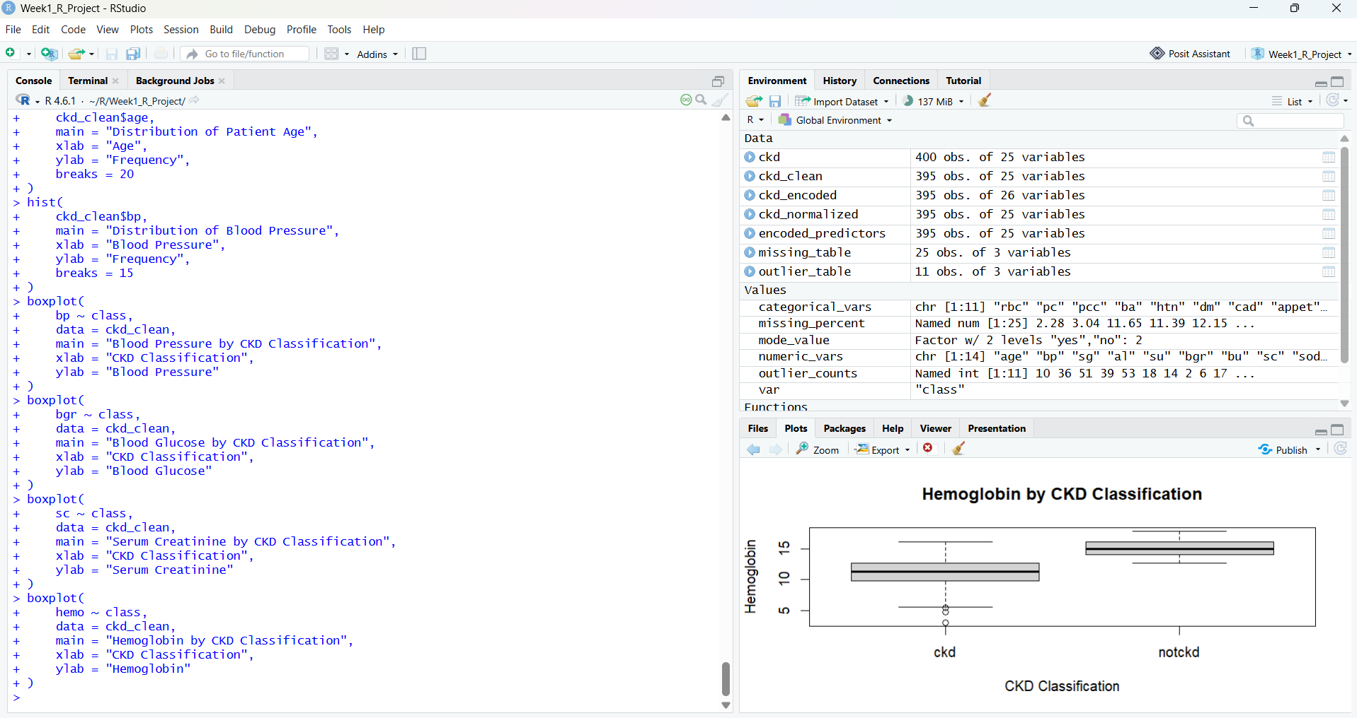
Figure 8. Haemoglobin by CKD classification.

7. Numerical Normalization
Numerical variables are measured on very different scales. For example, age is measured in years, blood glucose can be in the hundreds, and white blood cell count is measured in cells/cumm. To make the predictors comparable for later modelling, the project prepared a normalized dataset using min-max scaling. This transforms each numeric variable to the range 0 to 1 without changing the relative ordering of observations.
# Min-max normalization
normalize_minmax <- function(x) {
(x - min(x, na.rm = TRUE)) /
(max(x, na.rm = TRUE) - min(x, na.rm = TRUE))
}
ckd_normalized <- ckd_clean
ckd_normalized[numeric_vars] <-
lapply(ckd_normalized[numeric_vars], normalize_minmax)
summary(ckd_normalized[numeric_vars])
The RStudio Environment confirms creation of ckd_normalized with 395 observations and 25 variables. The normalized version is intended for downstream algorithms where scale differences could otherwise influence distance calculations or optimisation.

8. Exploratory Data Analysis

8.1 Descriptive statistics
The summary() function was used to inspect minimum, quartiles, median, mean and maximum values for numerical variables. This provides a baseline understanding of central tendency, spread and possible skewness.
summary(ckd_clean[numeric_vars])
The visible RStudio summary output reports, among other variables, age ranging from 2 to 90 years, blood pressure from 50 to 180, blood glucose from 74 to 490 in the displayed cleaned summary, serum creatinine extending to 76, haemoglobin approximately from 2.75 to 17.8, and white blood cell count extending to 26,400. These ranges illustrate why scale checking and outlier investigation are necessary.

8.2 CKD class distribution
table(ckd_clean$class)
prop.table(table(ckd_clean$class)) * 100
barplot(
table(ckd_clean$class),
main = "Distribution of CKD Classification",
xlab = "CKD Classification",
ylab = "Number of Patients"
)
The cleaned dataset contains 246 CKD observations and 149 non-CKD observations. This corresponds to 62.27% CKD and 37.72% non-CKD (rounding may differ by the last decimal place). The target is therefore not perfectly balanced, which should be considered before building a predictive model.

9. Correlation Analysis
Pearson correlations were calculated for the numerical variables to identify potentially related predictors. A heatmap was then used to make the pattern easier to inspect visually.
cor_matrix <- cor(
ckd_clean[numeric_vars],
use = "complete.obs"
)
round(cor_matrix, 2)
heatmap(
cor_matrix,
main = "Correlation Matrix of Numerical Variables"
)
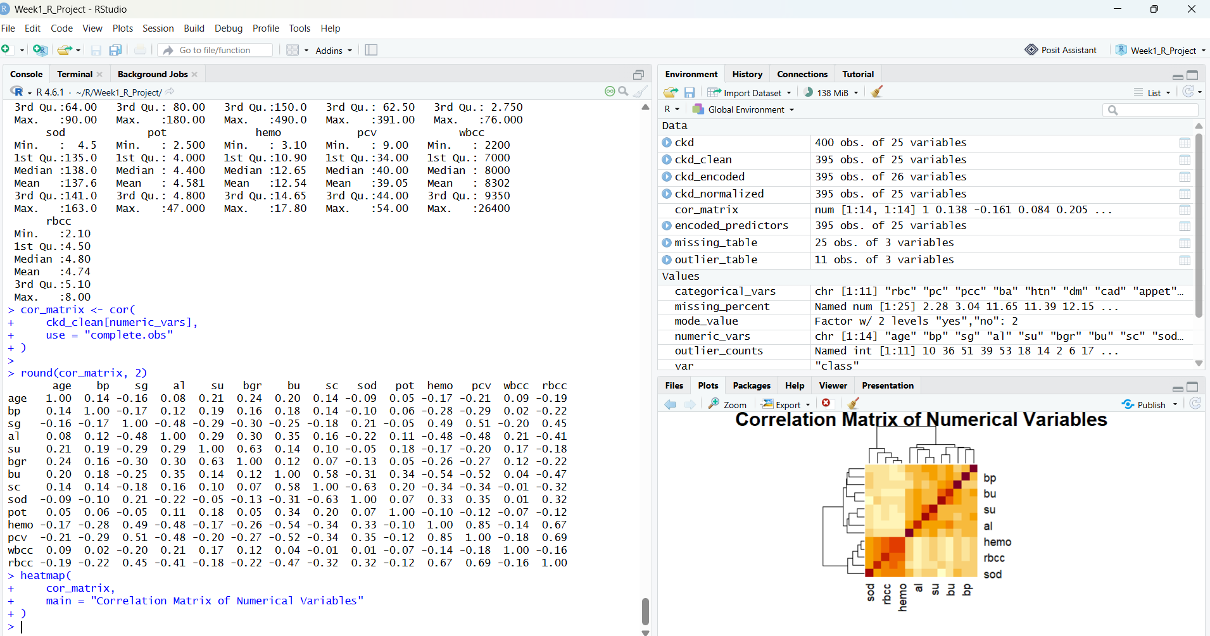
Figure 9. Correlation matrix and heatmap for numerical variables.
The displayed matrix shows several meaningful relationships. Examples include a strong positive association between haemoglobin and packed cell volume, a positive association between blood urea and serum creatinine, and a negative association between serum creatinine and sodium. Several variables have weak correlations, suggesting that the dataset contains complementary information rather than a single redundant numerical dimension.

10. Initial Findings and Interpretation
- The cleaned sample contains 395 observations, indicating that five original records were removed during the cleaning stage.
- CKD is the majority class in the cleaned sample: 246 patients versus 149 non-CKD patients.
- Age is concentrated in middle and older adult ranges, while a small number of very young observations are visible as low-end outliers.
- Blood pressure is concentrated mainly around the 60–90 range, with a long right tail and a small number of very high observations.
- Blood glucose is substantially more dispersed in the CKD group, with multiple high-value observations.
- Serum creatinine shows a particularly strong separation in the displayed boxplot: the CKD group has a much higher centre and much larger upper-tail variability.
- Haemoglobin is generally lower in the CKD group than in the non-CKD group, with several low observations.
- The correlation matrix highlights relationships among laboratory measurements, but also shows that many predictors are only weakly related.
These findings are exploratory and should not be interpreted as clinical conclusions or as evidence that any single variable causes CKD. They are useful for understanding the structure of the dataset and selecting sensible variables and preprocessing methods for a future predictive-modelling stage.
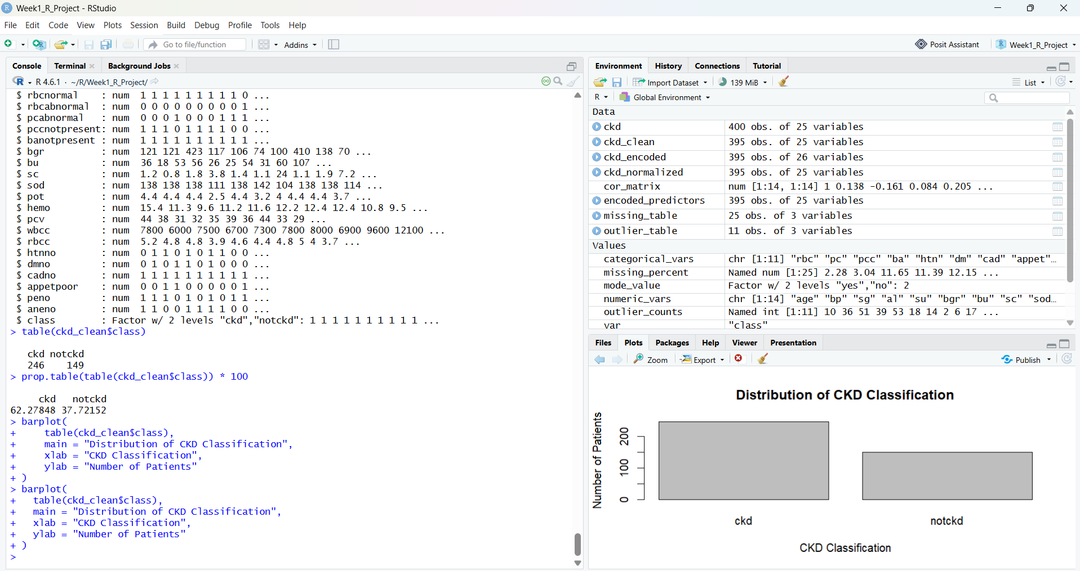
Figure 10. CKD classification distribution in RStudio.

11. Data-Processing Pipeline
Stage | Purpose | R approach | Output
1. Import | Read raw data and identify missing symbols | read.csv(..., na.strings='?') | ckd
2. Inspect | Understand dimensions, types and distributions | dim(), str(), summary(), head() | Initial profile
3. Missingness | Quantify incomplete observations | is.na(), colSums(), colMeans() | missing_table
4. Cleaning | Make variables usable and complete | type conversion + imputation | ckd_clean
5. Outliers | Detect extreme observations | IQR rule | outlier_table
6. Encoding | Convert categorical predictors for modelling | factor / integer encoding | ckd_encoded
7. Scaling | Put numerical predictors on a common scale | min-max normalization | ckd_normalized
8. EDA | Find patterns and relationships | hist(), boxplot(), barplot(), cor(), heatmap() | Plots + insights

12. Consolidated R Script for Submission
The following compact script brings the major Week 1 steps together. It can be placed in an R script file and rerun after the dataset filename/path is updated.
# ==============================
# WEEK 1 - CKD DATA PREPROCESSING
# ==============================
library(dplyr)
# 1. Import
ckd <- read.csv("chronic_kidney_disease.csv",
na.strings = c("?", "", "NA"),
stringsAsFactors = FALSE)
# 2. Define variable groups
numeric_vars <- c("age","bp","bgr","bu","sc","sod","pot",
"hemo","pcv","wbcc","rbcc")
categorical_vars <- c("sg","al","su","rbc","pc","pcc","ba",
"htn","dm","cad","appet","pe","ane")
# 3. Inspect
dim(ckd)
str(ckd)
summary(ckd)
head(ckd)
# 4. Missing-value report
missing_table <- data.frame(
variable = names(ckd),
missing_count = colSums(is.na(ckd)),
missing_percent = round(colMeans(is.na(ckd)) * 100, 2)
)
# 5. Create cleaned data
ckd_clean <- ckd
# Convert numerical columns
ckd_clean[numeric_vars] <- lapply(
ckd_clean[numeric_vars],
function(x) as.numeric(as.character(x))
)
# Convert categorical columns
ckd_clean[categorical_vars] <- lapply(
ckd_clean[categorical_vars], factor
)
# Impute numeric variables using median
for (v in numeric_vars) {
ckd_clean[[v]][is.na(ckd_clean[[v]])] <-
median(ckd_clean[[v]], na.rm = TRUE)
}
# Mode function
get_mode <- function(x) {
ux <- na.omit(x)
tab <- table(ux)
names(tab)[which.max(tab)]
}
# Impute categorical variables using mode
for (v in categorical_vars) {
ckd_clean[[v]][is.na(ckd_clean[[v]])] <-
get_mode(ckd_clean[[v]])
}
# 6. Outlier detection
outlier_counts <- sapply(ckd_clean[numeric_vars], function(x) {
q1 <- quantile(x, 0.25)
q3 <- quantile(x, 0.75)
iqr <- q3 - q1
sum(x < q1 - 1.5 * iqr | x > q3 + 1.5 * iqr)
})
outlier_table <- data.frame(
variable = names(outlier_counts),
outlier_count = as.integer(outlier_counts)
)
# 7. Encode binary variables
ckd_encoded <- ckd_clean
binary_vars <- c("rbc","pc","pcc","ba","htn","dm","cad",
"pe","ane")
for (v in binary_vars) {
ckd_encoded[[v]] <-
as.integer(factor(ckd_encoded[[v]])) - 1
}
ckd_encoded$class_encoded <-
ifelse(ckd_encoded$class == "ckd", 1, 0)
# 8. Normalize numerical variables
normalize_minmax <- function(x) {
(x - min(x)) / (max(x) - min(x))
}
ckd_normalized <- ckd_clean
ckd_normalized[numeric_vars] <-
lapply(ckd_normalized[numeric_vars], normalize_minmax)
# 9. Target distribution
table(ckd_clean$class)
prop.table(table(ckd_clean$class)) * 100
# 10. Correlation
cor_matrix <- cor(ckd_clean[numeric_vars],
use = "complete.obs")
round(cor_matrix, 2)
# 11. Visualisations
barplot(table(ckd_clean$class),
main = "Distribution of CKD Classification",
xlab = "CKD Classification",
ylab = "Number of Patients")
hist(ckd_clean$age,
main = "Distribution of Patient Age",
xlab = "Age",
ylab = "Frequency",
breaks = 20)
hist(ckd_clean$bp,
main = "Distribution of Blood Pressure",
xlab = "Blood Pressure",
ylab = "Frequency",
breaks = 15)
boxplot(bp ~ class, data = ckd_clean,
main = "Blood Pressure by CKD Classification",
xlab = "CKD Classification",
ylab = "Blood Pressure")
boxplot(bgr ~ class, data = ckd_clean,
main = "Blood Glucose by CKD Classification",
xlab = "CKD Classification",
ylab = "Blood Glucose")
boxplot(sc ~ class, data = ckd_clean,
main = "Serum Creatinine by CKD Classification",
xlab = "CKD Classification",
ylab = "Serum Creatinine")
boxplot(hemo ~ class, data = ckd_clean,
main = "Hemoglobin by CKD Classification",
xlab = "CKD Classification",
ylab = "Hemoglobin")
heatmap(cor_matrix,
main = "Correlation Matrix of Numerical Variables")

13. Conclusion
The Week 1 objective was achieved by taking a real-world, publicly available CKD dataset through a reproducible data-cleaning and preliminary-analysis workflow in R. The analysis began with structural inspection and missing-value profiling, followed by type conversion, imputation, outlier detection, categorical encoding and numerical normalization. Exploratory plots and correlation analysis were then used to identify the most visible patterns in the cleaned data.
The results demonstrate why preprocessing is essential for this dataset. The original 400 records were reduced to 395 usable observations after cleaning, and the final target distribution contained 246 CKD and 149 non-CKD observations. The exploratory figures indicate that variables such as serum creatinine, blood glucose and haemoglobin differ visibly between CKD and non-CKD groups. These findings provide a strong foundation for a future modelling phase involving feature selection, train/test splitting, classification algorithms and performance evaluation.

14. References
- UCI Machine Learning Repository. Chronic Kidney Disease dataset. https://archive.ics.uci.edu/dataset/336/chronic+kidney+disease
- Rubini, L., Soundarapandian, P., & Eswaran, P. (2015). Chronic Kidney Disease dataset. UCI Machine Learning Repository.

